**Screenshots of the game:**

**In first level I have completed the below tasks**

* **Obstacles**
* **On reaching the pole next level**
* **Sound effects**
* **Lighting**
* **Player movement**

**In second level I have completed the below tasks**

* **3 lifes of the player**
* **Cannot go out of the boundary**
* **Win caption**
* **Different type of patrol obstacle in 2nd level**

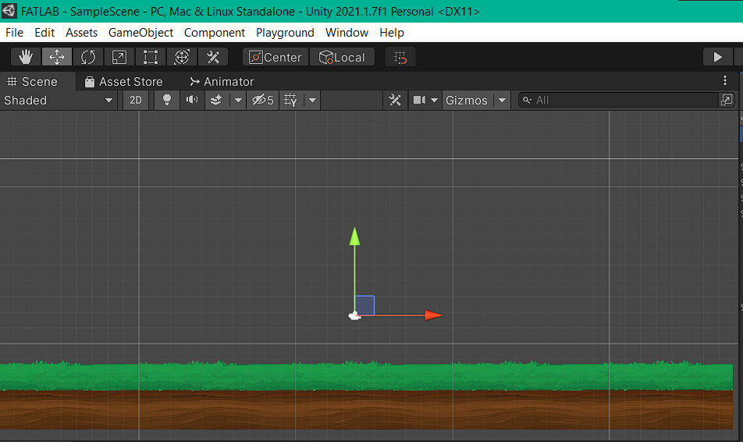

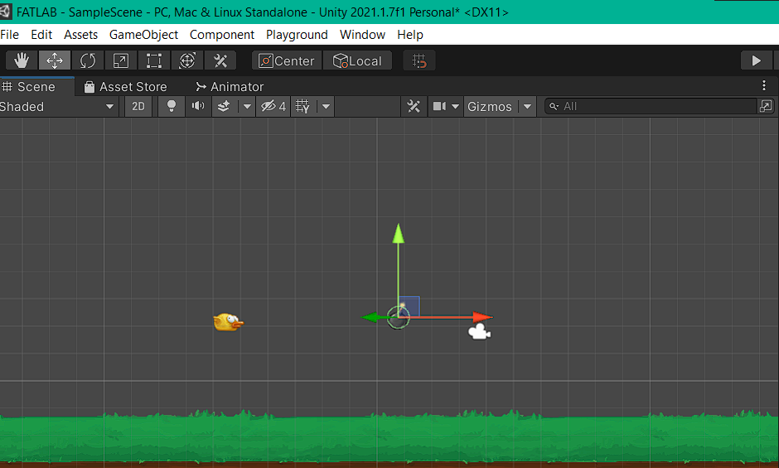

**For some enemy bomb sprites auto move is given**

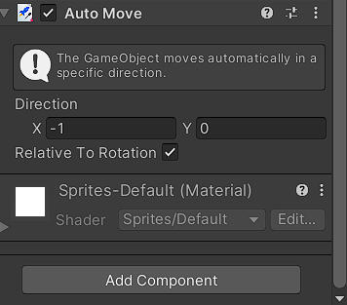

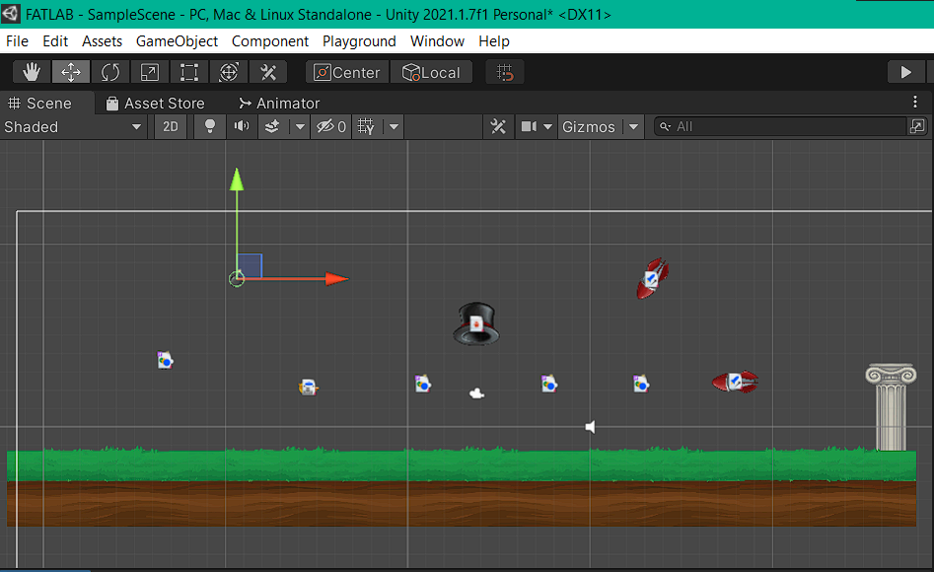

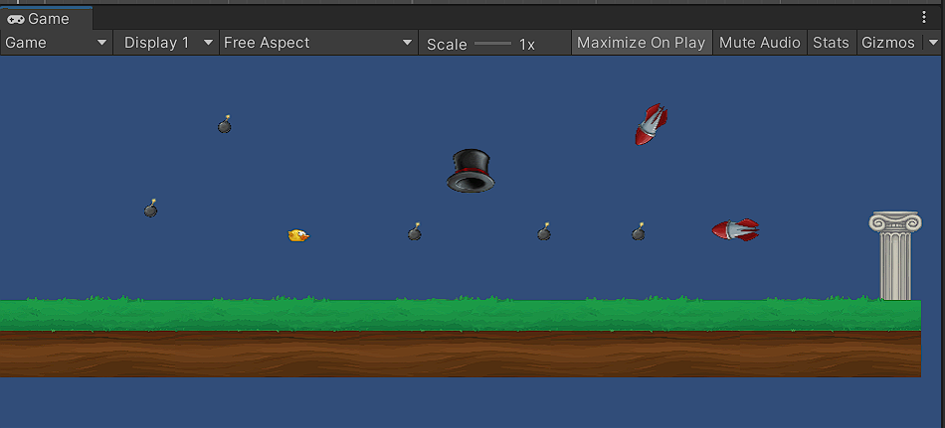

**From the hat bombs will be spanning**

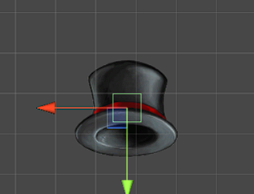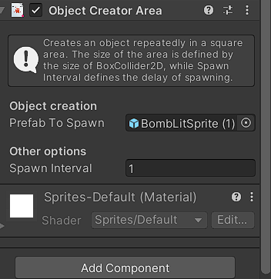

**Follow the player is given for some other enemy sprites as shown**

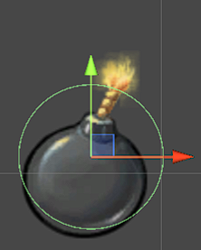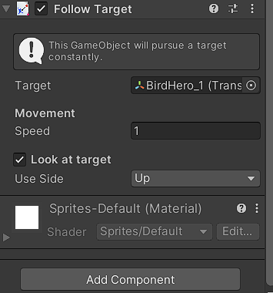

**Audio is given to play the music in the level**

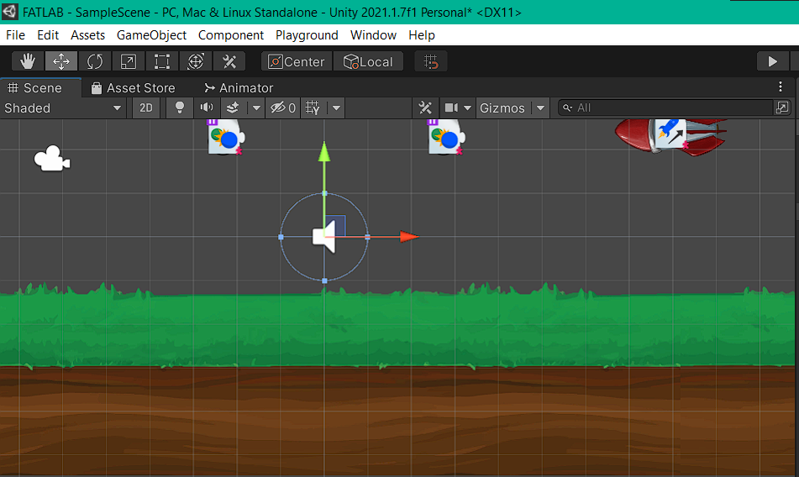

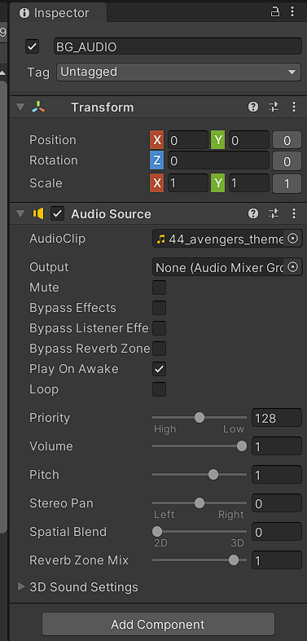

**Lighting:**

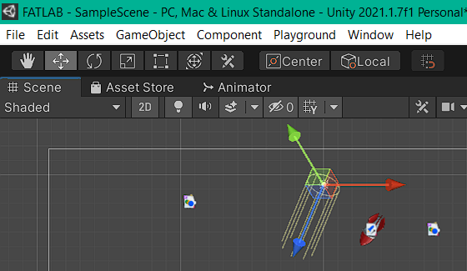

**Final level 1 design:**

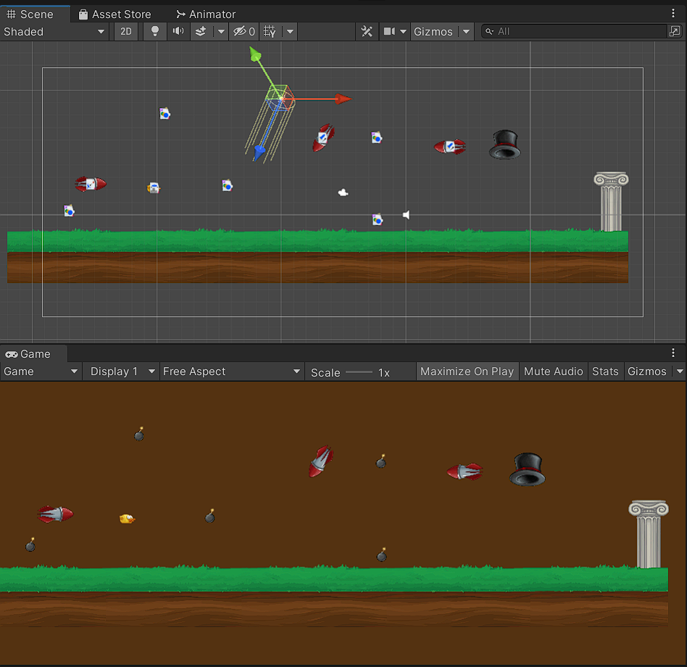

**On reaching the pole in the first level it redirects to 2nd level**

**Levels are created**

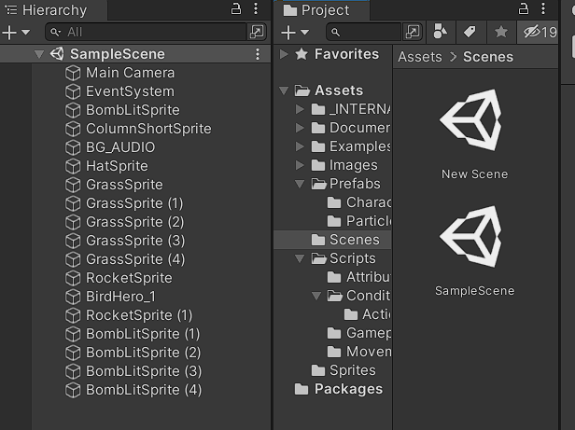

**Now level 2 starts:**

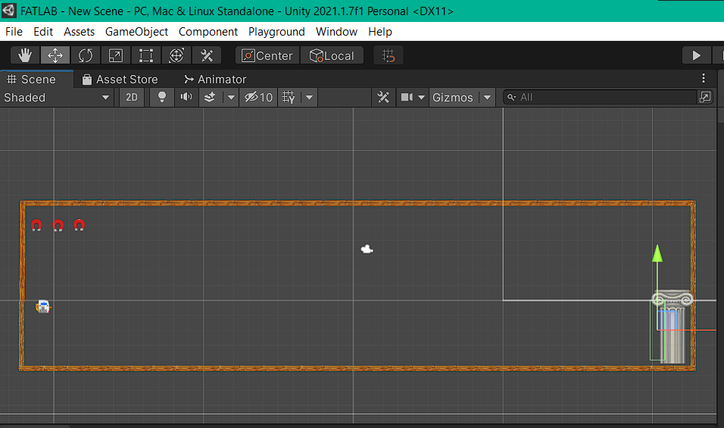

**In the above picture the 3 magnets are lifes of the player**

**On getting into contact with the obstacles one magnet becomes less and game ends if all the 3 lifes are over.**

**The pole is the goal,On reaching the pole you get win text**



**Created boundaries with the help of colliders as shown above.**

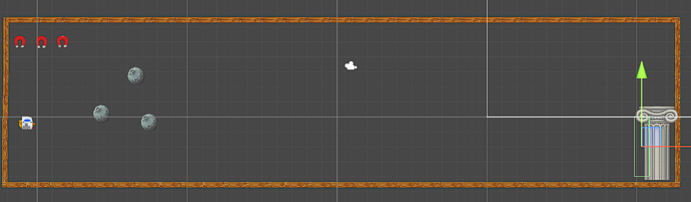

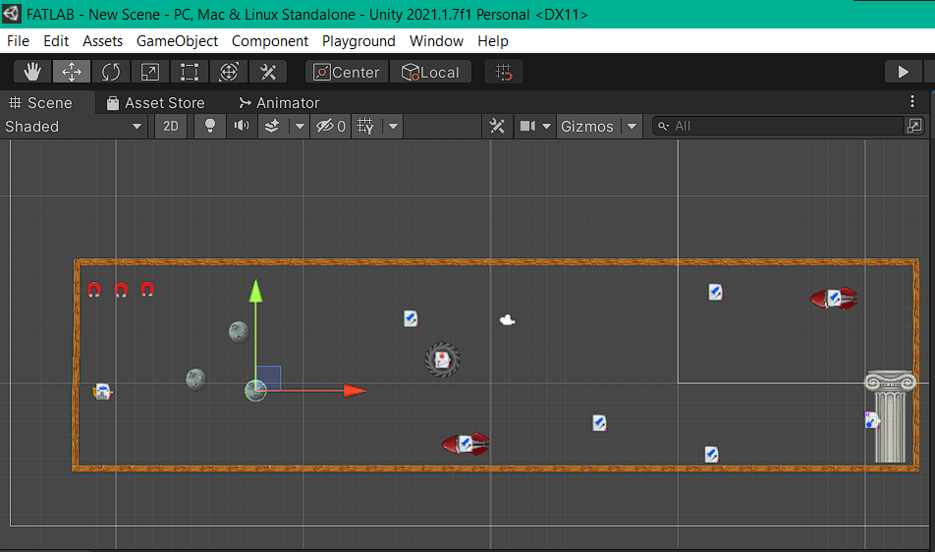

**Added several obstacles of different type in this 2nd level**

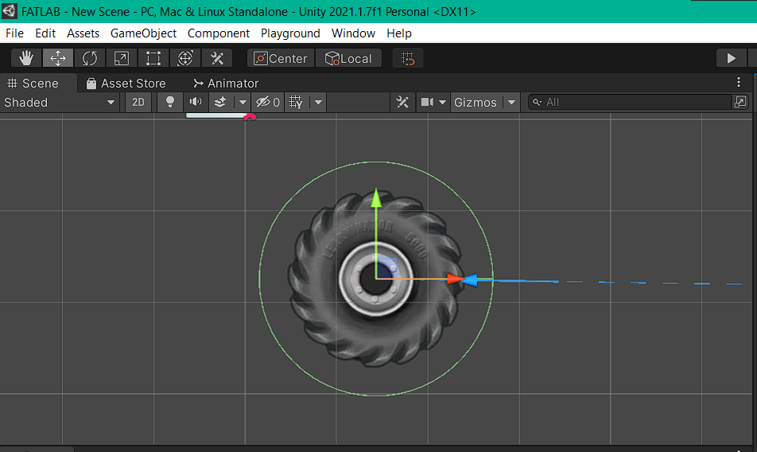

**Used the patrol script for the wheel to patrol in a area as the enemy**

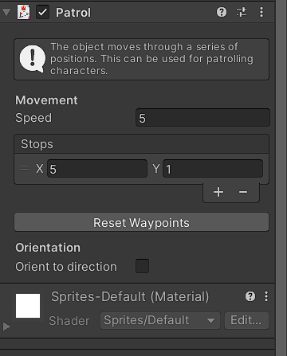

**Second level complete design**

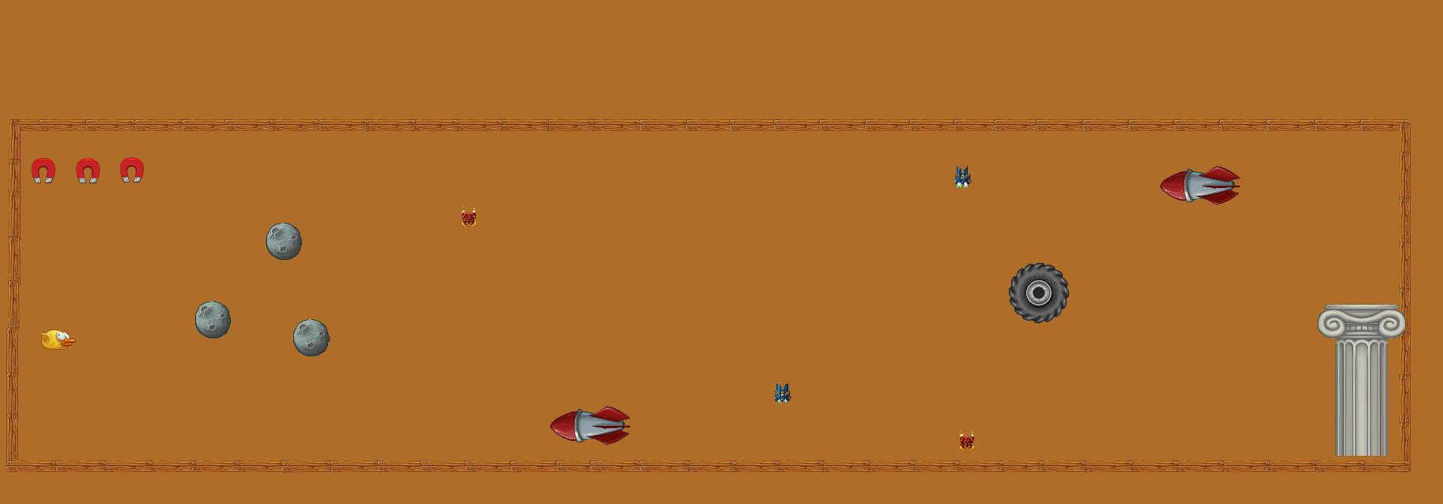

**Connecting the levels**

